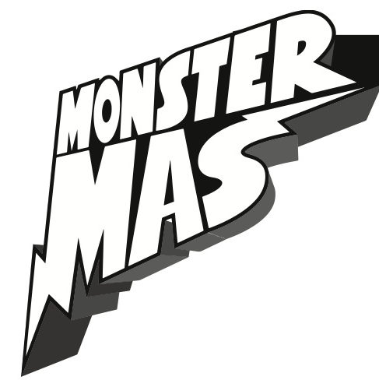

Bullies, Bullies,
Bullies are not nice,
Learning to treat others better
is the spice of life!

OHHHH

Bullies, Bullies,
Bullies like to hit
Keeping a positive attitude and
friendships help them Quit…..

Bullies, Bullies,
Bullies like to break rules
Not listening to the teacher and
Getting in trouble, not cool!

OHHHHH

Bullies, Bullies,
Bullies say bad things,
That’s not nice for anyone but
compliments make the zing….

Bullies, Bullies,
Bullies need some help
Life might be tough sometimes so
Tell a teacher, parent, YELP!!!

OHHHHH

Friends, Friends,
Friends learn to get along
Caring about each other
Helps us sing the right song…..

Bullying
Isn’t Cool
!!!!!

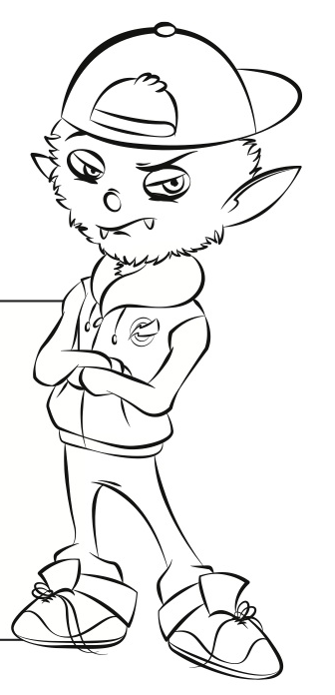

Composed by: Heather Arabadjis
www.monstermas.com

